The Italy Drawings: Digital Prints
Fill out form and email to: mequitta@automythography.com
Picture | Description | Price | Write Desired Quantity in Box
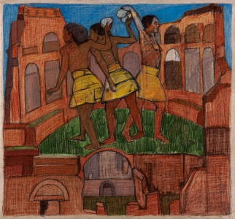 | Colle Palatino I 17”X18.25”  2014  Print from scanned original | $250.00  Free shipping to U.S.48 states  M.D. residents, add sales tax. | 0
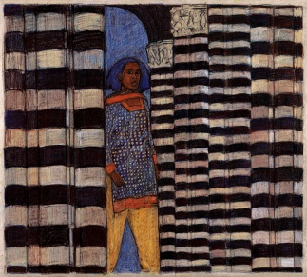 | Duomo  17”X19.25”  2014  Print from scanned original | $250.00  Free shipping to U.S.48 states  M.D. residents, add sales tax. | 0
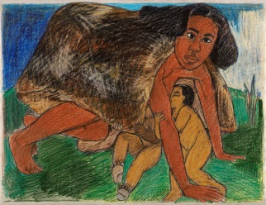 | Lupa I  17”X22”  2014  Print from scanned original | $250.00  Free shipping to U.S.48 states  M.D. residents, add sales tax. | 0
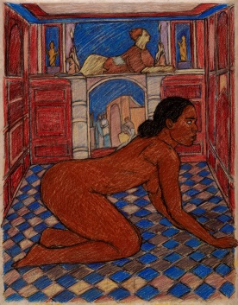 | Sphinx II  22”X17”  2014  Print from scanned original | $250.00  Free shipping to U.S.48 states  M.D. residents, add sales tax. | 0
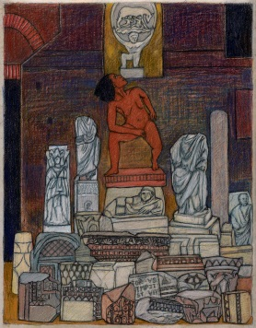 | Statues  22”X17”  2014  Print from scanned original | $250.00  Free shipping to U.S.48 states  M.D. residents, add sales tax. | 0
SET OF ALL FIVE | 5 prints | $1,000  Ships free to U.S.48. M.D add sales tax. | 0
Total Price Total Number of Prints
 | Order Tally:
Collector’s Name:  Delivery Address:  Email address: |  | Mail check to:  Mequitta Ahuja  3504 Parkside Drive  Baltimore, MD 21214  You will receive an order confirmation by email.

